

STAT250 Applied Statistics
Final Group Project Report
Group 11
Analysis of political violence and protest events in Turkey
2614428 Hasan Akkaya
2666436 Aslı Ceren Aksu
2666568 Ahmet Genç

Instructor: Prof. Burçak Başbuğ Erkan
Research Assistant: Burcu Koca Güler
Middle East Technical University
Department of Statistics
June 2026

CONTENTS

1. ABSTRACT 3
2. INTRODUCTION 3
3. DATA AND METHODOLOGY 3
3.1 Data Source 3
3.2 Data Cleaning and Restructuring 3
3.3 Derived Variables 4
3.4 Observational Data Limitation 4
4. EXPLORATORY DATA ANALYSIS 5
4.1 Event Type Distribution 5
4.2 Yearly Trends 5
4.3 Geographic Distribution 6
4.4 Fatality and Reporting Coverage Summary 6
4.5 Correlation Structure 7
5. STATISTICAL ANALYSIS AND RESEARCH QUESTIONS 8
5.1 Research Question 1: Event Type Composition and Fatality Status 8
5.2 Research Question 2: Fatal Event Rate in Violent and Non-Violent Events 9
5.3 Research Question 3: Reporting Structure and Event Severity 9
5.4 Research Question 4: Population Context of Event Types 11
5.5 Research Question 5: Regression Model for Event Severity 12
6. CONCLUSION AND LIMITATIONS 14
6.1 Summary of Findings 14
6.2 Limitations 14
6.3 Connection to SDG 16 15
7. REFERENCES 15

ABSTRACT
This study analyzes recorded political violence and protest events in Turkey between 2016 and 2023 using event-level data from the Armed Conflict Location and Event Data Project (ACLED) [1]. The original dataset contained 32,447 rows and 31 variables. After cleaning and restructuring the data at the event level, the final dataset consisted of 22,110 recorded events. The topic is connected to Sustainable Development Goal 16: Peace, Justice and Strong Institutions, because the dataset covers recorded violence, protest activity, fatality status, and reporting coverage.
Five research questions were examined using proportion tests, a chi-square test of independence, Welch’s t-test, Welch’s ANOVA, and regression analysis. The results show that protests made up the majority of recorded events, violent events had a much higher fatal event rate than non-violent events, fatal events were associated with slightly higher reporting coverage on average, and event types differed significantly in their population context. In the regression model, violent event classification showed the most prominent positive association with reported event severity. Since the dataset is observational, all findings are interpreted as associations rather than causal effects.

INTRODUCTION
Between 2016 and 2023, Turkey experienced a coup attempt, prolonged armed conflict in southeastern regions, and large-scale urban protests. This makes it a relevant case for examining how political disorder is recorded and distributed across event types, locations, and years. Understanding these patterns can help describe the structure of recorded political violence and protest activity in a specific country context. This study uses event-level data from the Armed Conflict Location and Event Data Project (ACLED), which systematically records political violence and protest events around the world. The dataset covers Turkey between 2016 and 2023 and includes information on event type, location, reported fatalities, actors involved, and reporting sources. The topic is connected to Sustainable Development Goal 16: Peace, Justice and Strong Institutions, which focuses on peaceful and inclusive societies, access to justice, and accountable institutions. We do not claim to calculate an official SDG indicator or evaluate institutional performance. Rather, we use this connection to motivate the relevance of studying recorded violence, protest activity, fatality status, and reporting coverage.
The analysis is organized around five research questions. The first question examines whether protests make up the majority of recorded events and whether fatality status is associated with event type. The second question compares fatal event rates between violent and non-violent events. The third question investigates whether fatal events are associated with higher reporting coverage than non-fatal events. The fourth question examines whether different event types are recorded in areas with different population contexts. The fifth question uses regression analysis to explore which variables are associated with recorded event severity.
Since the data come from an observational source, the findings in this report should not be interpreted as evidence of causal relationships. All results are described using associative language such as “is associated with,” “differs by,” or “appears higher.” The report first describes the data and methodology, then presents the exploratory data analysis, followed by the statistical analysis for each research question. The final section summarizes the main findings and discusses the limitations of the study.

DATA AND METHODOLOGY

3.1 Data Source
The data used in this study come from the Armed Conflict Location and Event Data Project (ACLED). ACLED is a disaggregated conflict monitoring project that collects, analyzes, and maps reported political violence and protest events across the world. The raw dataset used in this study covered Turkey between 2016 and 2024 and contained 32,447 rows and 31 variables before any cleaning was applied.

3.2 Data Cleaning and Restructuring
The raw dataset was not directly suitable for statistical analysis because some events appeared in more than one row. Therefore, the first step was to reorganize the data so that each row in the final dataset represented one unique recorded event. This was important because repeated event records could overstate event counts and affect descriptive summaries, visualizations, and statistical test results. During this process, ID formats were standardized, date and numeric variables were converted to appropriate types, and text and category variables were cleaned for consistency.
Several specific decisions were made during cleaning. The fatalities variable was treated according to the ACLED Codebook, which states that when there is no information on fatalities, the event is recorded as 0 reported fatalities. Therefore, missing values in fatalities were filled with zero for the purpose of this analysis. For the source_scale variable, missing values were first filled using the most common source scale recorded for the same reporting source when possible, and then the overall mode was used for any remaining missing values. The timestamp variable also had a small number of missing values. These were filled using the corresponding event_date converted to Unix timestamp format . This was done only to avoid missing values in the variable and was not interpreted as the original ACLED upload timestamp.
During the event-level restructuring, actor and source information from repeated records was preserved and summarized through variables such as actor_count and source_count. Population information was also combined into population_for_analysis, which was later log-transformed because the original population values were highly skewed.
The year 2024 was excluded from the final analysis because it contained only eight recorded events. Keeping this year in the dataset would create an incomplete year problem and make yearly comparisons less reliable. After cleaning, restructuring, and restricting the analysis period, the final dataset covered 2016 to 2023 and contained 22,110 recorded events and 65 variables.

3.3 Derived Variables
Several variables were created from the cleaned dataset to support statistical analysis. Table 1 summarizes the main variables used in the project, including their types and roles in the analysis.
Table 1. Main variables used in the analysis.
Variable | Description | Type | Use in the Project
event_type | Main ACLED event category (e.g., Protests, Riots, Battles). | Categorical | Used to compare event composition and fatality patterns across event types.
admin1 | First-level administrative division (province). | Categorical | Used for province-level descriptive analysis.
latitude, longitude | Geographic coordinates of the recorded event location. | Numerical | Used to show the spatial distribution of recorded events.
fatalities | Number of reported fatalities associated with an event. | Numerical | Represents the number of reported fatalities for each event.
fatal_event | Indicator showing whether an event resulted in at least one reported fatality. | Binary | Coded as 1 if an event has at least one reported fatality and 0 otherwise.
violent_event | Indicator showing whether an event belongs to a violent event category. | Binary | Coded as 1 for events classified as Battles, Explosions/Remote violence, Violence against civilians, or Riots.
source_count | Number of sources reporting the event. | Numerical / discrete | Used as an indicator of reporting coverage.
actor_count | Number of actors recorded as participating in the event. | Numerical / discrete | Used as an event characteristic in the regression model.
population_for_analysis | Population proxy linked to the event location. | Numerical | Used as a population proxy for the event location.
log_population | Log-transformed version of the population variable. | Numerical | Log-transformed population proxy used to reduce skewness.
log_fatalities | Log-transformed fatality count calculated as log(1 + fatalities). | Numerical | Defined as log(1 + fatalities) and used as the response variable in regression.

The population proxy variable was constructed using a cascade approach: population_best was used first, followed by population_5km, population_2km, and population_1km as fallback options. Any remaining missing values were filled with the median. Since population values were highly right-skewed, a log transformation was applied to create log_population.

3.4 Observational Data Limitation
The dataset is observational. Events are recorded based on available media and source reports, which means the data reflect what was reported rather than a complete census of all events that occurred. All statistical results in this report are interpreted as associations between recorded variables and should not be used to make causal claims.

EXPLORATORY DATA ANALYSIS
Before applying formal statistical tests, descriptive statistics and visualizations were used to examine the cleaned dataset. The main patterns observed here are connected to the research questions in Section 5, and they show how recorded violence, protest activity, reported fatalities, and reporting coverage are distributed across event types, years, and locations.

4.1 Event Type Distribution
Table 2. Frequency and percentage of recorded events by event type, 2016–2023.
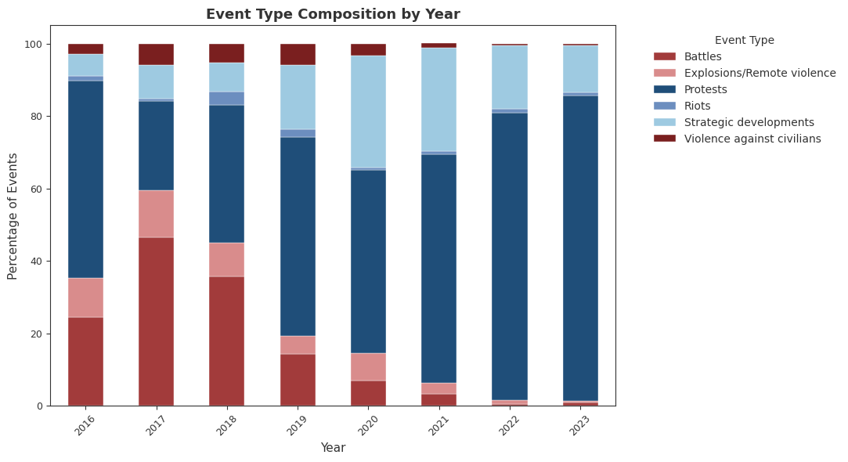
The dataset contains six types of events: Protests, Strategic developments, Battles, Explosions/Remote violence, Violence against civilians, and Riots. Table 2 presents the frequency and percentage of each event type. Protests are the most frequently recorded event type, accounting for approximately 57.8% of all recorded events. Strategic developments are the second most common category. Violent types of events such as Battles, Explosions/Remote violence, Violence against civilians, and Riots make up a smaller but still important part of the dataset.
This distribution shows that recorded events are not evenly distributed across event types. In particular, the high share of protests motivates the first research question, which formally tests whether protests make up more than half of all recorded events. At the same time, the presence of different violent and non-violent event types makes it necessary to examine whether fatality status differs by event type.

4.2 Yearly Trends
Yearly patterns were examined to describe how recorded events, reported fatalities, and fatal event rates changed between 2016 and 2023. Figure 1 presents the yearly number of recorded events, total reported fatalities, and fatal event rate. The number of recorded events increased after the first year of the study period and remained relatively high for several years. In contrast, reported fatalities were more concentrated in the earlier years of the period. This pattern should be interpreted together with the broader security context of the period. ACLED notes that the beginning of 2016 was marked by escalating violence in southeastern Turkey as part of the renewed Kurdish/Turkish conflict, and International Crisis Group reported that the Turkey-PKK conflict had killed almost 3,000 people between July 2015 and July 2017 . This context helps explain why the earlier years of the dataset, especially 2016 and 2017, may show higher reported fatality levels.
These yearly patterns are descriptive and should not be interpreted as evidence of a causal time trend. Changes in source availability, recording practices, or the types of events recorded may all affect the observed yearly patterns. However, the yearly summary is still useful because it provides background for understanding the overall structure of the dataset before moving to formal statistical tests.
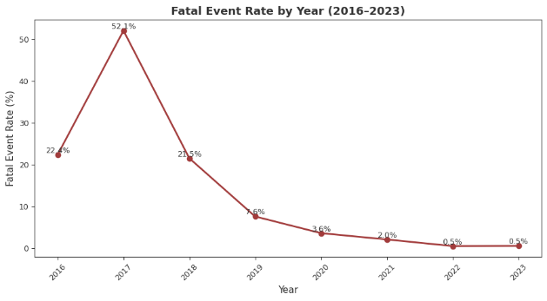
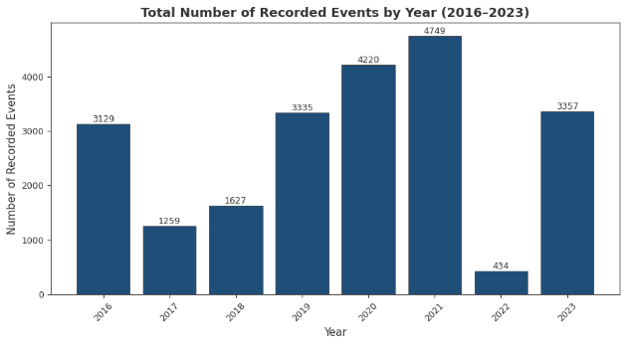
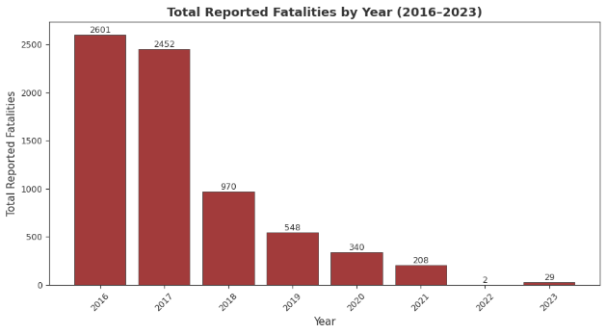
Figure 1. Yearly trends in recorded events, reported fatalities, and fatal event rate, 2016–2023.

4.3 Geographic Distribution
The geographic distribution of recorded events was examined using latitude, longitude, and province-level information. Figure 2 shows the spatial distribution of all recorded events and fatal events across Turkey. Recorded events appear across many parts of the country, while fatal events appear more concentrated in certain eastern and southeastern provinces.
This spatial pattern should be interpreted descriptively rather than causally, as the observed concentration of fatal events in eastern and southeastern provinces is consistent with the conflict context described in Section 4.2.
Province-level summaries were also used to compare event frequency and reported fatalities. Table 3 presents the top 15 provinces by total recorded events and by total reported fatalities. This comparison is useful because provinces with the highest number of recorded events are not necessarily the same as provinces with the highest number of reported fatalities. In other words, event frequency and event severity do not always follow the same geographic pattern.
This geographic contrast supports the use of a population context variable in the fourth research question. Since events are recorded in different locations and population settings, it is useful to examine whether event types differ in their population context.
Figure 2. Spatial distribution of recorded events and fatal events in Turkey, 2016–2023.
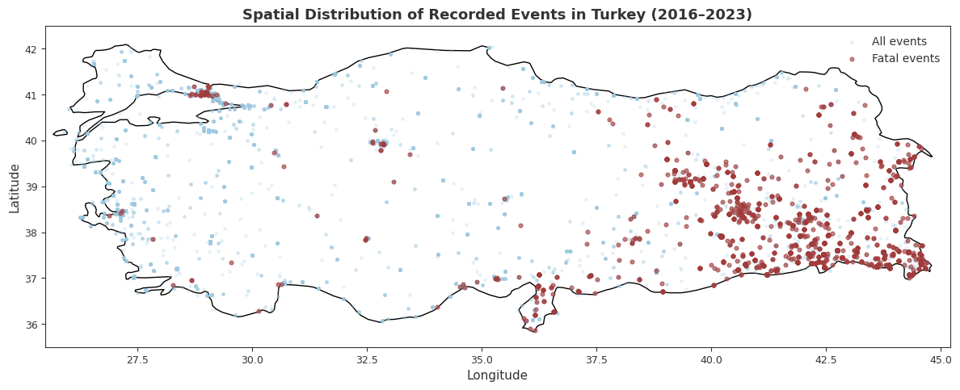
Figure 3. Top 15 provinces by recorded event count and by total reported fatalities, 2016–2023.
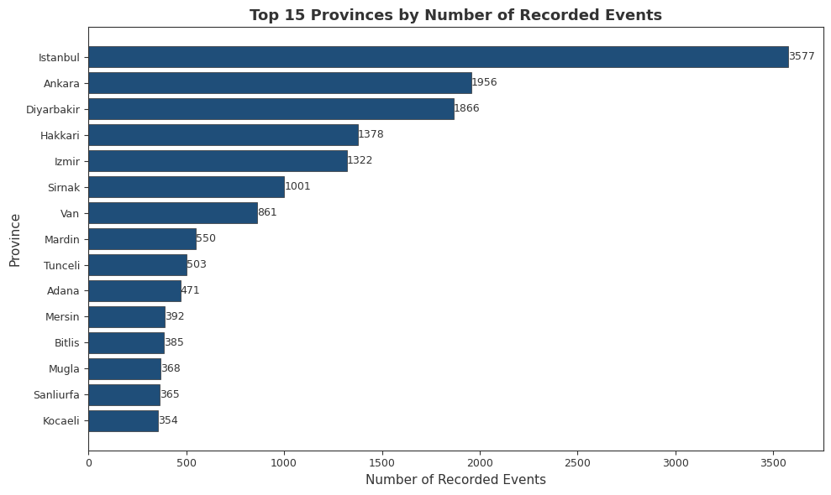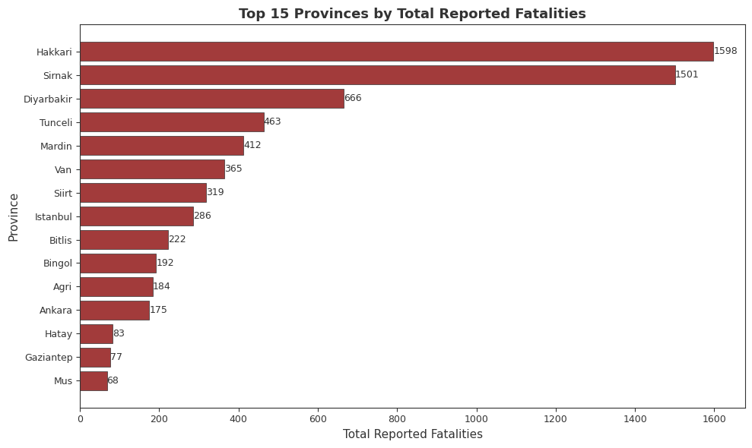

4.4 Fatality and Reporting Coverage Summary
Fatality-related variables were examined before formal tests because reported fatalities are central to several research questions. Out of 22,110 recorded events, 2,224 had at least one reported fatality. This corresponds to a fatal event rate of approximately 10.1%. The distribution of reported fatalities is highly right-skewed: most events have zero reported fatalities, while a smaller number of events account for larger fatality counts. This pattern is important because it shows that using only the raw fatalities variable would be difficult for some analyses. For this reason, the binary variable fatal_event was used in several research questions, and log_fatalities = log(1 + fatalities) was used in the regression model.
Reporting coverage was summarized using source_count, which represents the number of distinct sources recorded for each event. The average number of sources per event is approximately 1.31, while the median is 1. This shows that most recorded events have one source, although some events have multiple sources. Fatal events have a slightly higher average source count than non-fatal events. This pattern motivates the third research question, which formally examines whether fatal events are associated with higher reporting coverage.
Figure 4. Fatality status and reporting coverage summary, 2016–2023.
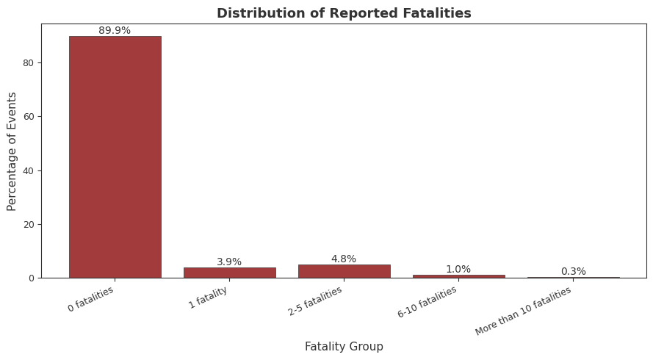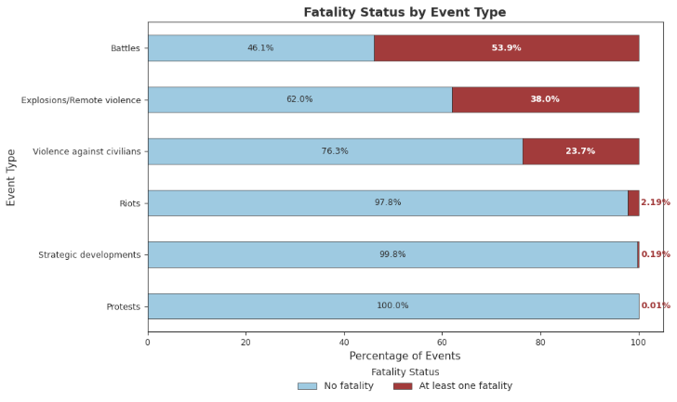

4.5 Correlation Structure
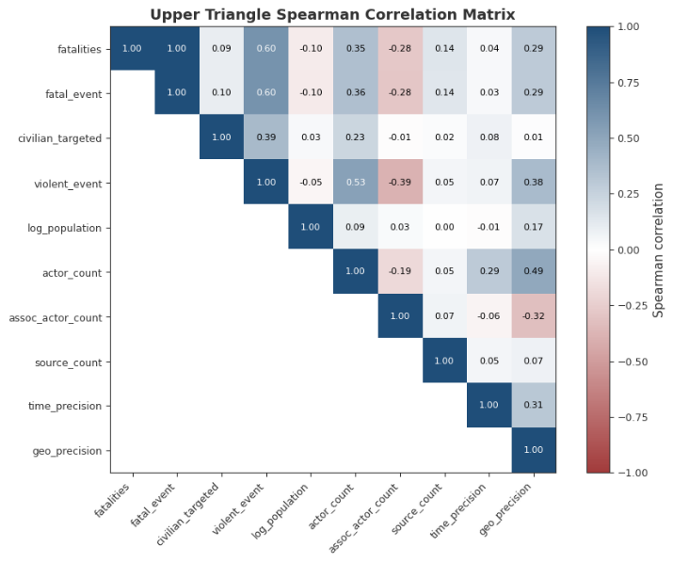
Figure 5. Spearman correlation matrix for main numerical variables.
A Spearman correlation matrix was computed for the main numerical variables used in the analysis. Spearman correlation was preferred because several variables in the dataset are discrete, skewed, or not normally distributed. Since the aim was to describe monotonic relationships rather than strictly linear ones, Spearman was more appropriate than Pearson correlation for this dataset. The strongest correlation is between fatalities and fatal_event, which is expected because fatal_event was created directly from the fatalities variable.
Among the other variables, source_count and actor_count show small positive correlations with fatalities. This suggests that events with more recorded sources or actors may also tend to have slightly higher reported fatality counts, but the relationships are not strong on their own. The correlation between log_population and fatalities is close to zero, suggesting no strong monotonic association in the descriptive correlation matrix.
These correlation results are exploratory and should not be interpreted as causal evidence. However, they help describe the relationships among the main numerical variables and support the variable selection for the regression model in the fifth research question.
Overall, the exploratory analysis shows that protests are the most common recorded event type, reported fatalities are concentrated in a smaller subset of events, event frequency and reported fatalities differ geographically, and reporting coverage varies across events. These patterns provide the descriptive background for the formal statistical analyses in the next section.

STATISTICAL ANALYSIS AND RESEARCH QUESTIONS

5.1 Research Question 1: Event Type Composition and Fatality Status
Are protests the majority of recorded events, and is fatality status associated with event type?
This question is analyzed in two parts using a one-sample proportion z-test and a chi-square test of independence. The proportion test examines whether protests form a statistically significant majority of all recorded events. The chi-square test examines whether fatality status differs across event types.
Part A — Are protests the majority of recorded events?
Let p be the proportion of recorded events classified as protests. The hypotheses were:
H₀: p = 0.50
Hₐ: p > 0.50
The alternative is one-sided because "majority" means more than half. The large-sample condition was satisfied since both n × p₀ and n × (1 − p₀) equaled 11,055 under the null hypothesis, well above the minimum threshold.
Table RQ1.1. One-sample proportion z-test results.
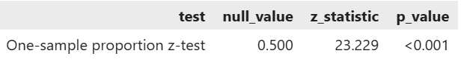
As shown in Table RQ1.1, 12,782 out of 22,110 recorded events were protests, giving a sample proportion of 0.578. The z-test gave z = 23.229 and p < 0.001. We rejected H₀ and concluded that protests formed a statistically significant majority of recorded events.
Part B — Is fatality status associated with event type?
The hypotheses for the chi-square test were:
H₀: Event type and fatality status are independent.
Hₐ: Event type and fatality status are associated.
All expected cell frequencies were above five, with a minimum of 27.561, so the chi-square condition was satisfied.
Table RQ1.2. Fatal event rates by event type and chi-square test result.
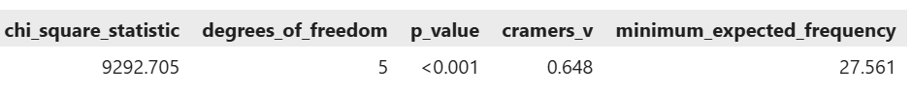
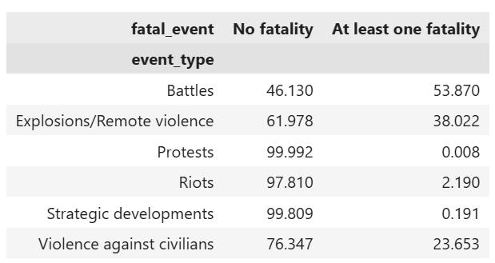
Table RQ1.2 shows that Battles had the highest fatal event rate at 53.9%, followed by Explosions/Remote violence at 38.0% and Violence against civilians at 23.7%. Protests and Strategic developments had very low fatal event rates. The chi-square test confirmed that these differences were statistically significant, χ²(5) = 9292.705, p < 0.001. Cramér's V was 0.648, indicating a strong association between event type and fatality status.
Taken together, these results show that the dataset is heavily shaped by protest activity, and that fatality patterns differ sharply across event types. The strong Cramér's V value is partly expected given that violent event categories such as Battles are defined in ways that make reported fatalities more likely by design. These findings describe associations in the recorded ACLED data and should not be interpreted as evidence that event type causes fatality outcomes.

5.2 Research Question 2: Fatal Event Rate in Violent and Non-Violent Events
This question compares the proportion of fatal events between violent and non-violent groups. Comparing raw fatal event counts alone would be misleading because the two groups have substantially different sample sizes. Therefore, a two-proportion z-test was used to compare fatal event rates directly. Each recorded event belonged to only one group, so the two groups were treated as independent.
Do violent events have a higher fatal event rate than non-violent events?
Violent events were defined as Battles, Explosions/Remote violence, Violence against civilians, and Riots. Protests and Strategic developments were classified as non-violent events. Let p₁ be the population proportion of fatal events among violent events and p₂ be the population proportion of fatal events among non-violent events.
H₀: p₁ = p₂
Hₐ: p₁ > p₂
Table RQ2.1. Group summaries and large-sample condition check.
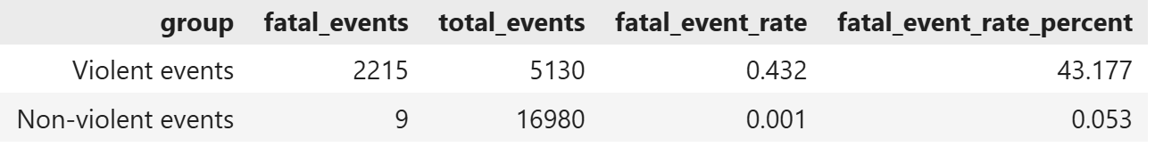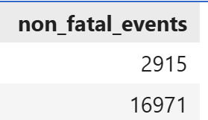
As shown in Table RQ2.1, 2,215 of the 5,130 violent events were fatal, corresponding to a fatal event rate of 43.177%. In comparison, 9 of the 16,980 non-violent events were fatal, corresponding to a fatal event rate of 0.053%.
The non-violent group contained only 9 fatal events, which is slightly below the commonly used minimum count of 10 for the normal approximation. Therefore, the large-sample condition was not fully satisfied, and the two-proportion z-test result should be interpreted with some caution. Nevertheless, the observed difference between the two sample proportions was very large.
Table RQ2.2. Two-proportion z-test result.
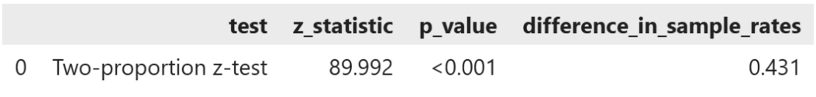
Table RQ2.2 shows that the z-statistics were 89.992 and p < 0.001. We rejected H₀ and concluded that violent events had a higher fatal event rate than non-violent events in the recorded data. The estimated difference in fatal event rates was 0.431, meaning that the fatal event rate among violent events was approximately 43.1 percentage points higher. The 95% confidence interval for this difference ranged from 0.418 to 0.445.
Since the p-value was below 0.001, the decision to reject H₀ remained unchanged across all standard significance levels.
This result shows a large difference in recorded fatal event rates between the two groups. However, it should be read as an association rather than a causal finding. The classification of events as violent or non-violent is based on ACLED event type definitions, and violent categories are defined in ways that make reported fatalities more likely by design.

5.3 Research Question 3: Reporting Structure and Event Severity
Are more severe events associated with broader reporting coverage?
In this analysis, event severity was represented by fatal_event, and reporting coverage was measured using source_count. More severe events may attract attention from a larger number of sources, which motivated this comparison.this However, source_count only reflects the number of sources recorded in the ACLED dataset and should not be treated as a complete measure of media attention or reporting quality.
The analysis proceeded in two steps. First, the overall distribution of source_count was summarized descriptively. Then, mean source counts were compared between fatal and non-fatal events using a formal hypothesis test.
Table RQ3.1. Descriptive reporting coverage summary.
Table RQ3.1 shows that the mean source count across all 22,110 recorded events was 1.313, with a median of 1. Around 22.03% of events were reported by more than one source. This shows that most recorded events had only one source, and multi-source reporting was the exception rather than the rule.
Table RQ3.2. Source count summary by fatal event status.
Table RQ3.2 compares source counts between fatal and non-fatal events. Fatal events had a mean source count of 1.641 compared with 1.276 for non-fatal events, giving a mean difference of 0.365. However, both groups had a median source count of 1, which means the difference reflects a shift in the average rather than a widespread pattern of multi-source reporting for fatal events. Fatal events also had a higher share of multi-source reporting, at 38.3% compared with 20.2% for non-fatal events.
For the main comparison, let μ₁ be the population mean source count for fatal events and μ₂ be the population mean source count for non-fatal events. The hypotheses were:
H₀: μ₁ = μ₂
Hₐ: μ₁ > μ₂
The alternative is one-sided because the question asks whether fatal events have higher reporting coverage.
Before comparing the means, Levene's test was used to check whether the two groups had equal variances.
Table RQ3.3. Levene's test and Welch two-sample t-test results.
As shown in Table RQ3.3, Levene's test was significant with p < 0.001, so the equal variance assumption was not reasonable. Welch's two-sample t-test was therefore used instead of the pooled t-test, since Welch's test does not require equal variances. The t-statistic was 17.069 and p < 0.001. We rejected H₀ and concluded that fatal events had a higher mean source count than non-fatal events in the recorded data.
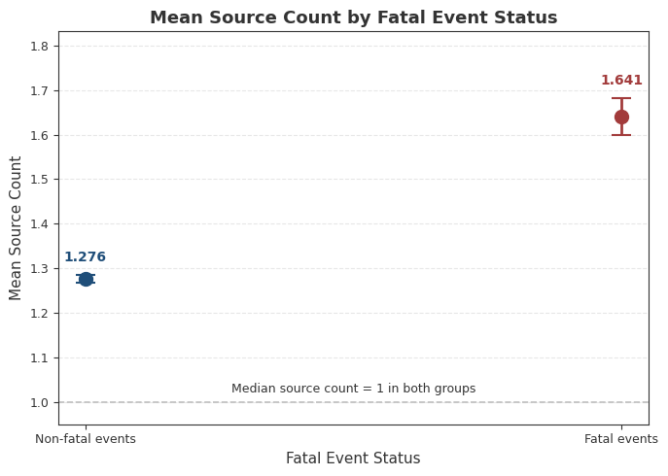
Table RQ3.4. Confidence interval and Mann–Whitney U sensitivity check.
Table RQ3.4 presents the 95% confidence interval for the mean difference, which ranged from 0.323 to 0.407. Since source_count is discrete and right-skewed, a Mann–Whitney U test was also used as a nonparametric sensitivity check. The test statistic was 26,409,867 with p < 0.001, supporting the Welch t-test result.
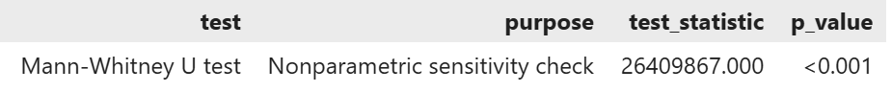
Fatal events were associated with higher average reporting coverage than non-fatal events in the recorded data. However, since both groups had a median source count of 1, this result should not be overstated. It reflects a difference in average recorded source counts and should be interpreted as an association rather than a causal effect.

5.4 Research Question 4: Population Context of Event Types
Do event types differ in their population context?
This question examines whether different event types tend to be recorded in locations with different population sizes. This is relevant because eastern provinces, where armed conflict was more concentrated during the study period, generally have lower population densities than western urban centers where protests were more common. If event types cluster in locations with systematically different population sizes, this would suggest that population context is associated with the type of political disorder recorded in a given area.
The response variable was log_population, which is the log-transformed version of the population proxy linked to each event location. The log transformation was applied because raw population values were highly right-skewed. The grouping variable was event_type, which has six categories. Since more than two groups were being compared, a one-way ANOVA framework was used. However, because equal variances across groups could not be assumed, Welch ANOVA was preferred over standard one-way ANOVA.
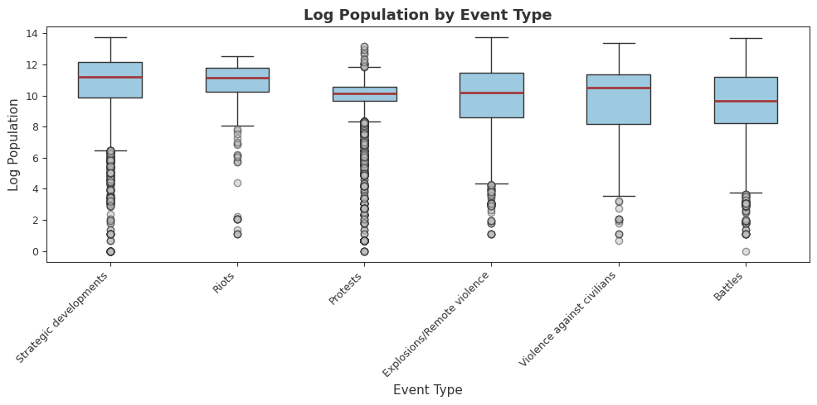
Figure RQ4.1. Distribution of log_population by event type.
Figure RQ4.1 compares the distribution of log_population across event types. Strategic developments and Riots have the highest median log_population values, while Battles have the lowest median. The boxplots also show that the spread of log_population differs across event types, and several groups contain observations with substantially lower population values. These descriptive differences suggest that event types may occur in different population contexts and motivate the formal comparison using Welch’s ANOVA. However, the boxplot alone does not show whether the observed differences are statistically significant.
Before running the ANOVA, Levene's test was used to check whether the equal variance assumption was reasonable.
Table RQ4.2. Levene's test and Welch ANOVA result.
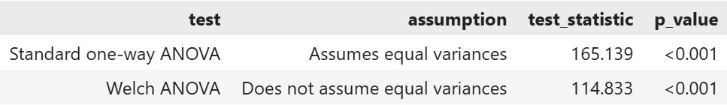
As shown in Table RQ4.2, Levene's test was significant with p < 0.001, confirming that equal variances across event types could not be assumed. Welch ANOVA was therefore used. The Welch ANOVA result was also significant with p < 0.001, indicating that mean log_population differed significantly across event types. Because the overall test was significant, pairwise comparisons were conducted to identify which specific pairs of event types differed.

Table RQ4.3. Pairwise comparisons with Holm correction.
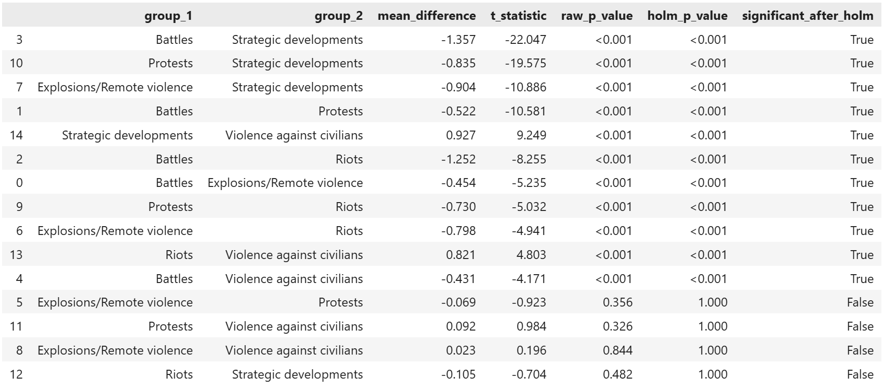
Since multiple pairwise comparisons increase the risk of false positives, Holm correction was applied to the pairwise p-values. Table RQ4.3 shows that several event type pairs remained statistically significant after correction, particularly those involving Battles or Strategic developments. Not all pairs were significantly different after the Holm correction.
To check whether the results were sensitive to the population proxy, a sensitivity analysis was conducted by excluding observations where log_population equaled zero. The Welch ANOVA result remained significant after this exclusion, confirming that the finding was not driven by these observations.
Event types differed significantly in their population context. Battles were recorded in locations with the lowest average population proxy, while Riots and Strategic developments were recorded in locations with the highest. These differences are described as associations between event type and population context in the recorded data and should not be interpreted as causal relationships.

5.5 Research Question 5: Regression Model for Event Severity
Which variables are associated with event severity among recorded events?
The fifth research question examines whether violent event classification, actor count, source count, and population context are associated with reported event severity. The response variable was log_fatalities, defined as: log_fatalities = log(1 + fatalities)
This transformation was used because the original fatality counts were highly right-skewed and contained many zero values. Adding 1 allowed events with zero reported fatalities to remain in the analysis. However, the transformed response remained zero-heavy. Therefore, the regression models were treated as exploratory association models rather than final predictive or causal models.
Two linear regression models were fitted. The simple model included only violent_event as a predictor. The multiple model was defined as:
log_fatalities = β₀ + β₁ violent_event + β₂ actor_count + β₃ source_count + β₄ log_population + ε
For each predictor, the coefficient hypotheses were:
H₀: βⱼ = 0
Hₐ: βⱼ ≠ 0
The simple model showed a positive association between violent event classification and log_fatalities, with an estimated coefficient of 0.521 and an R² value of 0.293. The multiple model increased R² to 0.311, meaning that the four predictors together explained approximately 31.1% of the observed variation in log_fatalities. The multiple model also had lower AIC and BIC values than the simple model, indicating better relative model fit after accounting for model complexity. However, the increase in explained variation was modest.
Table RQ5.1. Multiple regression results using HC3 robust standard errors.
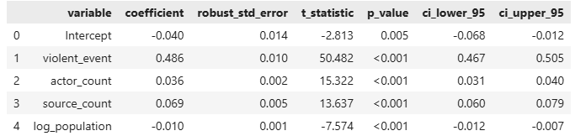
The multiple regression results showed that all four predictors were statistically significant at the 5% level. Holding the other variables constant, violent events had an expected log_fatalities value that was 0.486 units higher than non-violent events. Each additional recorded actor was associated with an increase of 0.036 in expected log_fatalities, while each additional recorded source was associated with an increase of 0.069. A one-unit increase in log_population was associated with a small decrease of 0.010 in expected log_fatalities.
Among the predictors, violent_event had the largest absolute t-statistic, suggesting that violent event classification was the most prominent predictor in the fitted model. This comparison is based on the magnitude of the t-statistic rather than the raw coefficient size, since the predictors are measured on different scales and their coefficients are not directly comparable.
Regression assumptions were checked after fitting the model because the residuals are obtained from the fitted values. The Breusch–Pagan test was statistically significant, with a test statistic of 3783.589 and p < 0.001. Therefore, the constant variance assumption was not satisfied, indicating heteroskedasticity. For this reason, HC3 robust standard errors were used for coefficient tests and confidence intervals. HC3 robust standard errors address heteroskedasticity in standard error estimation but do not correct for the zero-heavy distribution of the response variable or the non-normality of residuals. Therefore, model fit statistics such as R² should be interpreted with caution.
The Jarque–Bera test was also statistically significant, with a test statistic of 283482.144 and p < 0.001. The residuals had a skewness of 2.776 and kurtosis of 19.640, indicating that residual normality was not satisfied. The residual and Q-Q plots were consistent with these test results. Multicollinearity did not appear to be a major concern because the predictor VIF values ranged from 1.011 to 1.408, well below commonly used thresholds.
Figure RQ5.1. Residuals versus fitted values and Q-Q plot for the multiple regression model.
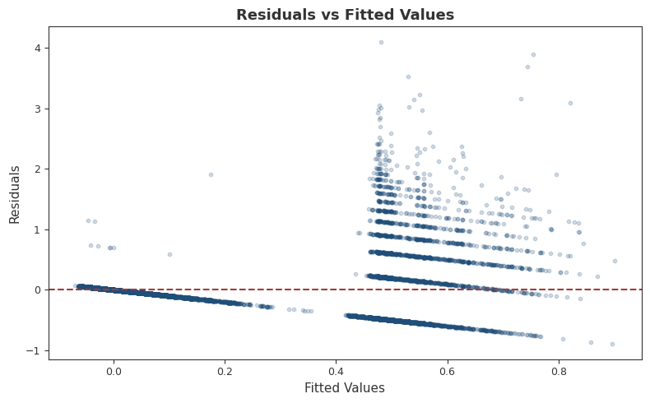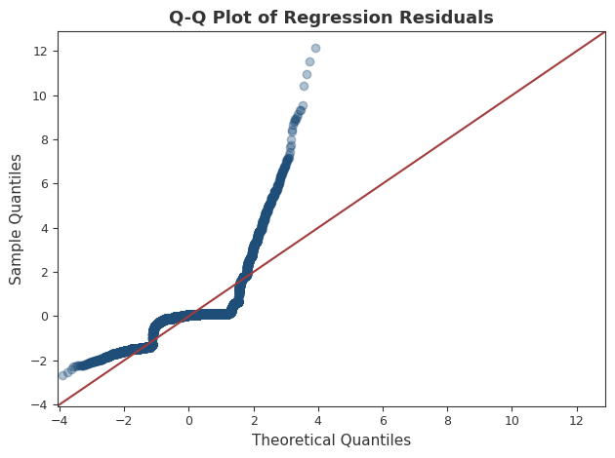
Overall, violent event classification, actor count, source count, and population context were statistically associated with reported event severity in the fitted model. Violent events showed the largest positive association, while log_population had a small negative association. However, the response variable remained zero-heavy, and the constant variance and residual normality assumptions were not satisfied. Therefore, the findings should be interpreted cautiously as exploratory associations within the recorded ACLED data rather than as causal effects or a final predictive model.

CONCLUSION AND LIMITATIONS
This section summarizes the main findings from the five research questions, discusses the limitations of the study, and connects the results to the broader context of SDG 16.

6.1 Summary of Findings
The first research question showed that protests made up approximately 57.8% of all recorded events, which was significantly more than half based on a one-sample proportion z-test. The chi-square test of independence also showed that fatality status was strongly associated with event type, with a Cramér's V of 0.648. Violent event types such as Battles and Explosions/Remote violence had much higher fatal event rates than Protests and Strategic developments.
The second research question compared fatal event rates between violent and non-violent events. The fatal event rate among violent events was approximately 43.2%, compared with 0.05% among non-violent events. A two-proportion z-test confirmed that this difference was statistically significant. The result shows a large difference in recorded fatal event rates between the two groups, although it should be read as an association rather than a causal finding.
The third research question examined whether fatal events were associated with higher reporting coverage. Fatal events had a higher mean source count than non-fatal events, with a mean difference of approximately 0.365. This difference was statistically significant based on Welch's two-sample t-test, and the Mann–Whitney U test gave the same conclusion as a nonparametric sensitivity check. However, both groups had a median source count of 1, so the result reflects a difference in average reporting coverage rather than widespread multi-source reporting for every fatal event.
The fourth research question examined whether event types differed in their population context. Welch ANOVA showed that mean log population differed significantly across the six event types. Battles were recorded in locations with the lowest mean log population, while Strategic developments and Riots were recorded in locations with the highest mean log population. Pairwise comparisons with Holm correction confirmed that several of these differences were statistically significant. The result was also robust after excluding observations with a log population value of zero.
The fifth research question used regression analysis to examine which variables were associated with recorded event severity. Violent event classification was the strongest predictor in both the simple and multiple regression models. Actor count and source count also had small positive associations with log reported fatalities, while log population had a small negative association. The multiple model explained approximately 31.1% of the variation in log fatalities. However, the constant variance and residual normality assumptions were not satisfied, and HC3 robust standard errors were used to reduce the effect of heteroskedasticity on coefficient inference.

6.2 Limitations
Several limitations should be kept in mind when interpreting these findings.
First, the dataset is observational. All results describe associations between recorded variables and should not be interpreted as causal effects. The analysis cannot explain why events occur where they do, why some events result in fatalities, or why reporting coverage differs across events.
Second, the data reflect what was reported and recorded by available sources rather than a complete picture of all events that occurred. Events in areas with limited media access or fewer reporting sources may be underrepresented in the dataset. This means that patterns in the data could partly reflect differences in recording coverage rather than differences in actual event frequency or severity.
Third, the population proxy used in this study was constructed from gridded population estimates linked to event coordinates. This variable is an approximation of the population size near an event location and does not represent the number of people directly affected by any event.
Fourth, the response variable in the regression analysis remained zero-heavy even after the log transformation. This limited the performance of the linear regression model and means that the regression results should be treated as an exploratory association model rather than a final predictive model.
Finally, the analysis covers only Turkey between 2016 and 2023. The findings describe patterns in this specific dataset and should not be generalized to other countries or time periods without further analysis.

6.3 Connection to SDG 16
This study is connected to Sustainable Development Goal 16, which focuses on peaceful and inclusive societies, access to justice, and strong institutions. The findings describe how recorded political violence and protest activity were distributed across event types, locations, and years in Turkey during the study period. The results show that protests were the dominant form of recorded political activity, that violent events were associated with much higher fatality rates, and that fatal events tended to have slightly higher reporting coverage. These patterns are relevant to SDG 16 because they describe how recorded violence, protest activity, and fatality patterns were distributed across Turkey during the study period. However, this study does not calculate an official SDG indicator and does not evaluate institutional performance or policy outcomes.

REFERENCES
https://acleddata.com/methodology/acled-codebook
United Nations. (2015). Transforming our world: The 2030 agenda for sustainable development (A/RES/70/1). United Nations General Assembly. https://sdgs.un.org/2030agenda
Armed Conflict Location and Event Data Project. (2016). ACLED Turkey 2016 data release. https://acleddata.com/2016/09/01/acled-turkey-2016-data-release/
International Crisis Group. (2017). Turkey's PKK conflict: A visual explainer. https://www.crisisgroup.org/europe-central-asia/western-europemediterranean/turkey/turkeys-pkk-conflict-visual-explainer

